8. Wpg Compliance for Log360

Tagline – Achieve Wpg compliance with centralized log collection and comprehensive audit trails using Log360.

Overview: The Wpg Compliance extension for Log360 helps organizations maintain full compliance with Wpg standards and requirements. By integrating this extension, IT and security teams gain deep visibility into their compliance posture and security controls.
Log360 continuously collects and correlates log data from Active Directory, Windows, Unix/Linux, Microsoft 365, cloud platforms, and network devices, mapping events directly to Wpg regulations. Security teams can track compliance status in real time, investigate incidents quickly, and generate audit-ready reports with a single click.

Key Features:
- Generate comprehensive audit-reports mapped to each of the Wpg regulatory requirements and controls.
- Provides powerful search capabilities with filters, keywords, and time-based queries for detailed forensic investigations.
- Correlates logs from different sources to detect threats, anomalies, and compliance violations with automated rules.
- Export reports in PDF and CSV format for auditors, management, or regulatory submissions.




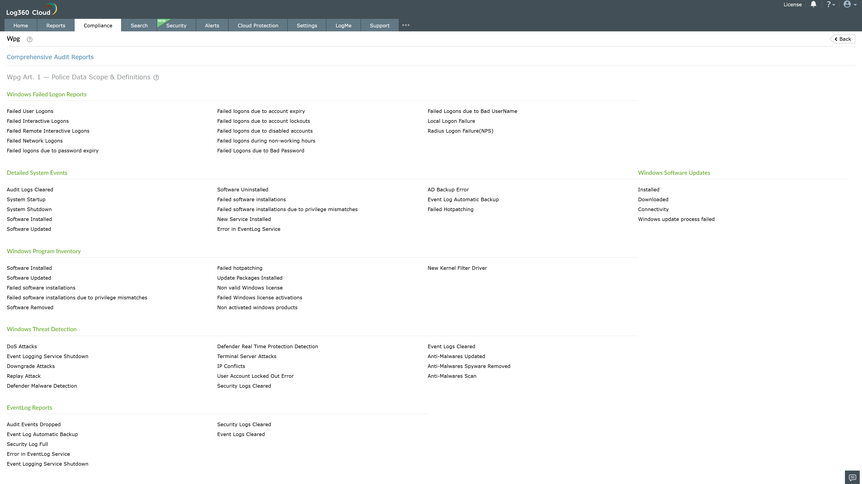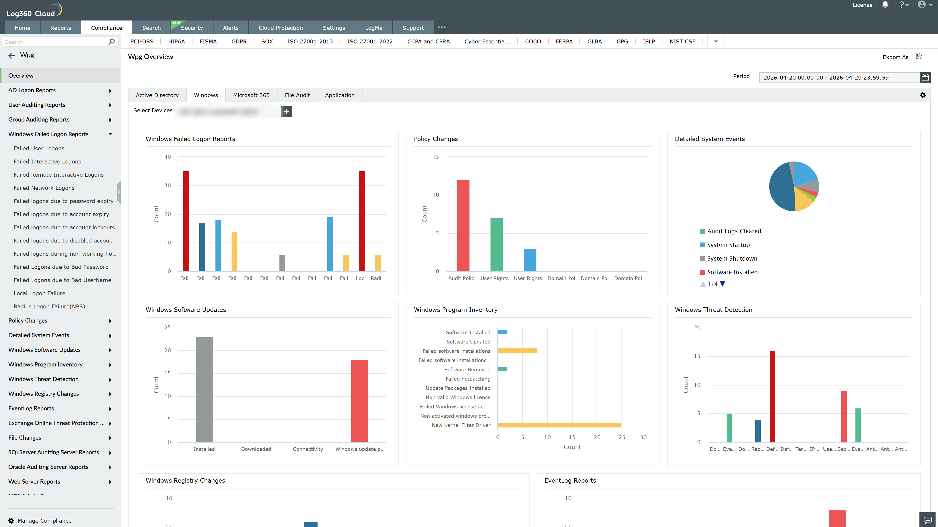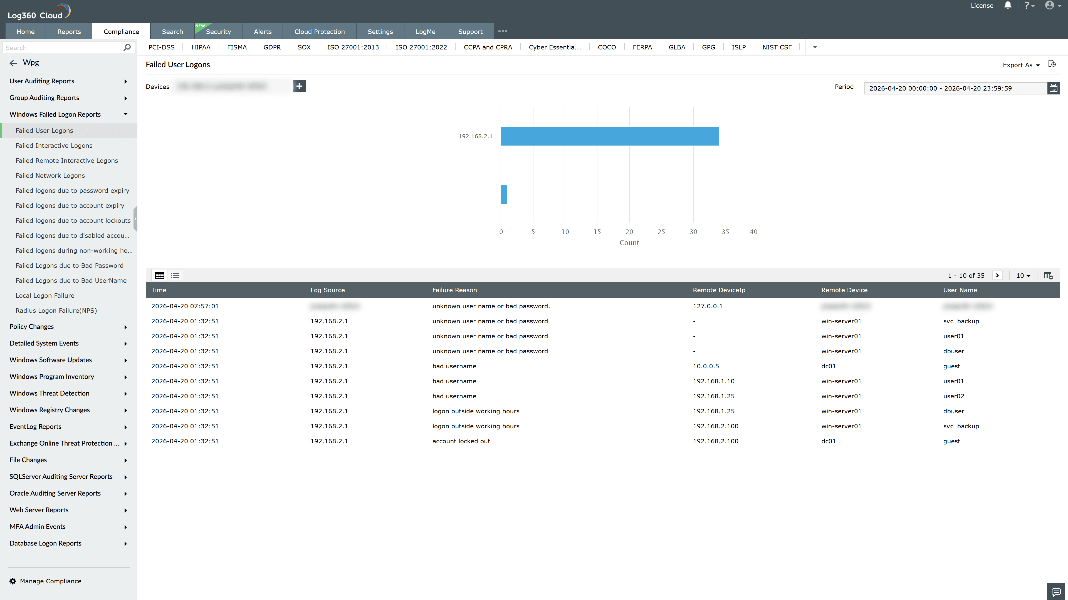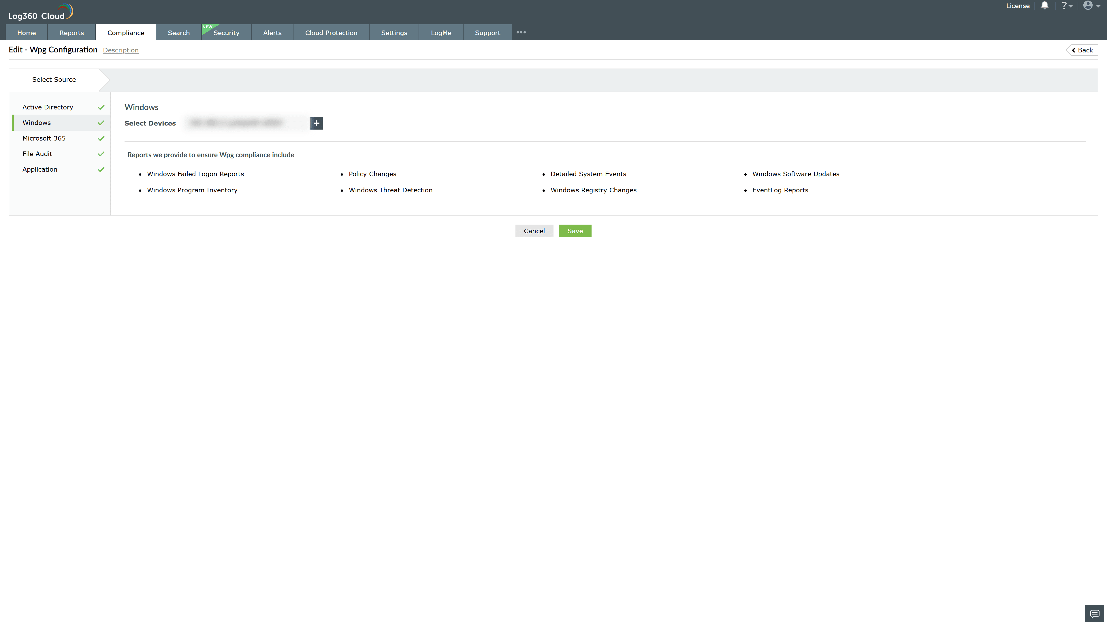

Valid Submission : Yes
Supported Editions : Free, Basic, Standard, Professional, MSSP
Help Document : https://www.manageengine.com/log-management/help/integrations/compliance-extensions.html
Help Video : Not provided
Tags : Log360, Compliance, Privacy monitoring, Data privacy, Regulatory compliance
Supported DCs : US, IN, JP, CA, AU, UK and EU
Privacy Policy:
Terms of Service:
Release Notes:
Predefined reports for the Wpg Compliance.

